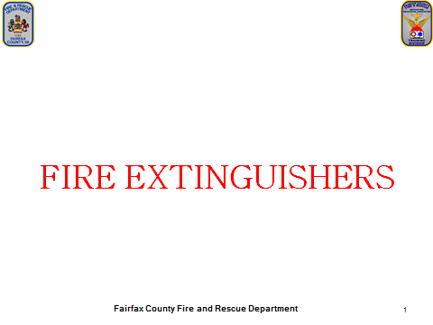
What You Should Know:
Introduce yourself
Class introductions

Administration:
Bathroom
Vending Machines
Emergency Evacuation
Location of High Bay

It is important for everyone in the fire department to know how to use a fire extinguisher. This is a basic skill for everyone. Yes, even those of you that are EMS Only should know how to use a fire extinguisher. There may be calls where the first arriving unit is the medic or ambulance. You could be the difference between someone losing their home with all their possessions and possibly even their life.

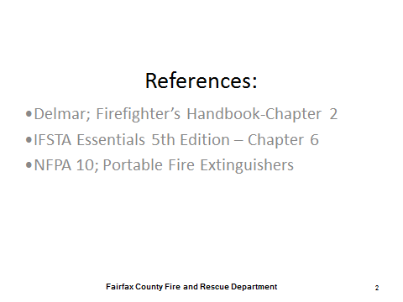
What You Should Know:
If you would like to know more about extinguishers, here are some of the references used in this presentation.

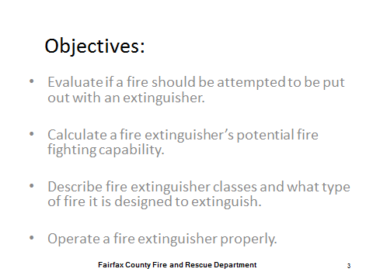
What You Should Know:
We have four learning objectives we plan on covering in this class. By the end of the class, you will be able to:
- Evaluate if a fire should be attempted to be put out with an extinguisher.
- Calculate a fire extinguisher’s potential firefighting capability.
- Describe fire extinguisher classes and what type of fire it is designed to extinguish.
- Operate a fire extinguisher properly.

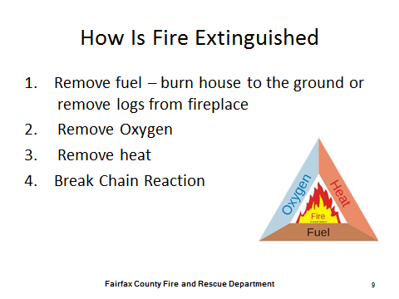
What You Should Know:
First we will discuss how a fire is extinguished. This is a fire tetrahedron. Those of you going onto fire school will become very familiar with this. In order to have fire, it needs to have a chemical reaction, which requires an oxidizing agent, heat, and fuel. If you take one of those away, you can break the chain reaction and put the fire out.

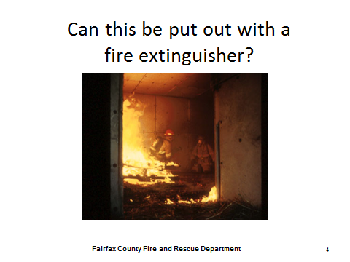
What You Should Know:
- Do you think this fire can be put out with a fire extinguisher? For me, yes. For you, probably not.
- What is an incipient fire? A fire in its beginning stage.
- This picture is an example of an incipient fire
- Portable fire extinguishers are designed to fight small incipient fires.

The incipient phase is the first phase of a fire. The oxygen content in the air has not been significantly reduced and the fire is producing water vapor, carbon dioxide, perhaps a small quantity of sulfur dioxide, carbon monoxide and other gases. Some heat is being generated, and the amount will increase with the progress of the fire. The fire may be producing a flame temperature well above 1,000⁰F (537⁰C), yet the temperature in the room at this stage may be only slightly increased.

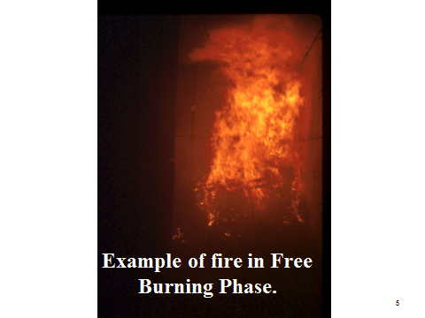

What You Should Know:
Could you put this out with a fire extinguisher? This is an example of a fire in the free burning phase.

During the free burning phase, oxygen-rich air is drawn into the flame as convection (the rise of heated gases) carries the heat to the upper most regions of the confined area. The heated gases spread out laterally from the top downward, forcing the cooler air to seek lower levels, and eventually igniting all the combustible material in the upper levels of the room. This heated air is one of the reasons that firefighters are taught to keep low and use protective breathing equipment. One breath of this super-heated air can sear the lungs. At this point, the temperature in the upper regions can exceed 1,300⁰F (700⁰C).

This type of fire won’t be put out with an extinguisher.

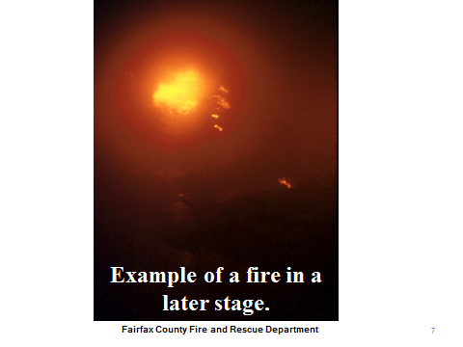
What You Should Know:
As the fire progresses through the latter stages of the free burning phase, it continues to consume the free oxygen until it reaches the point where there is insufficient oxygen to react with the fuel. The fire is then reduced to the smoldering phase and needs only a supply of oxygen to burn rapidly or explode. In this phase, flame may cease to exist if the area of confinement is sufficiently airtight. In this instance, burning is reduced to glowing embers. The room becomes completely filled with dense smoke and gases to the extent that it is forced from all cracks under pressure. The fire will continue to smolder, and the room will completely fill with dense smoke and gases of combustion at a temperature of well over 1,000⁰F (537⁰C). The intense heat will have vaporized the lighter fuel fractions such as hydrogen and methane from the combustible material in the room. These fuel gases will be added to those produced by the fire and will further increase the hazard to the firefighter and create the possibility of a backdraft.
An example you may have experienced with the smoldering phase is when a candle was lit, but gets blown out. If you put a flame just above the candle where the puff of smoke is the candle will relight even if the flame did not touch the wick.
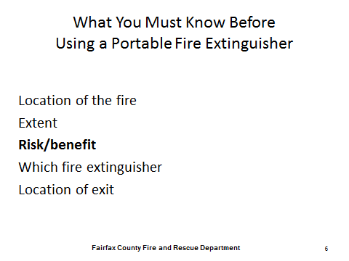

What You Should Know:
You will need to determine quickly if it is a fire that you can put out or not. Fire spreads rapidly and by the time you have pondered whether or not you are going to put it out, it has probably doubled in size. You need to be able to assess these questions rather quickly.
Do you know where the fire is located? You are not going to go into a high rise building searching for the fire with an extinguisher.
The extent of the fire. Is it an incipient fire or has it reached the free burning phase. Would it be in the free burning phase by the time you get there?
What is the risk/benefit analysis? Is it worth getting hurt or dying? Never risk your life or the lives of others for material objects.
Do you have an extinguisher and is it the right type and size for this fire?
If you were unable to put the fire out, how would you leave the room/building?

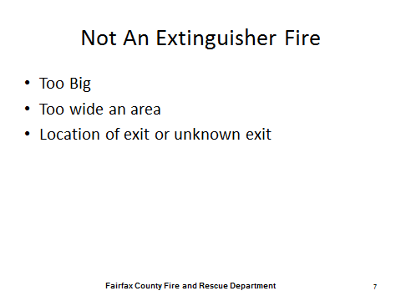
What You Should Know:
If the fire is already grown beyond the capability of your extinguisher you won’t be able to put it out. When going into a burning structure it is important to always know where you will exit. Never let the fire get between you and the exit. It is a good rule to always have the exit at your back.
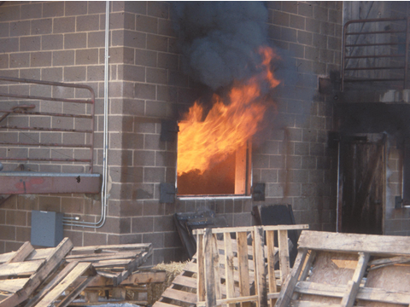

What You Should Know:
Is this a fire that can be put out with an extinguisher? What if there was a person trapped up stairs and the engine is 7 minutes out?
- Location of the fire – You can see where the fire is located on the ground floor
- Extent of the fire – You can see it is just one room
- Exit door – You can see that you have a door on the right
- Risk/Benefit – Someone’s life is in danger, you have gear and can easily attach the fire
  - I would go ahead and Gear Up

There are three different strategies that can be used to help get the person out.
- Shoot through the window to put fire out
- Shoot through the door to put fire out
- Hold the stairwell to get person out

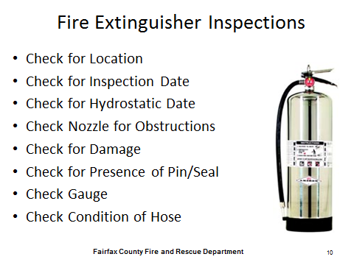
What You Should Know:
Here is a checklist of items to look for when inspecting the extinguisher. This is something you can do to contribute when riding as a red hat or EMS only.

- Check for Location
- Check for Inspection Date
- Check for Hydrostatic Date
- Check Nozzle for Obstructions
- Check for Damage
- Check for Presence of Pin/Seal
- Check Gauge
- Check Condition of Hose

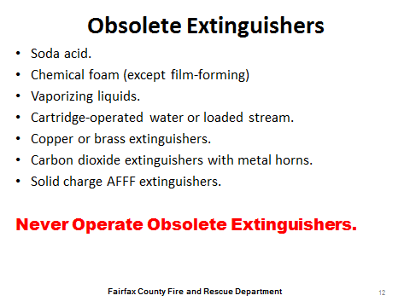
What You Should Know:
This is a list of extinguisher categories that have been identified as obsolete according to the 2002 edition of NFPA 10 referenced by the NFC (2005). These categories of obsolete fire extinguishers must not be in service and if found in service must be immediately removed, properly deactivated and disposed of, and replaced with an acceptable fire extinguisher of appropriate size and classification for the hazard.

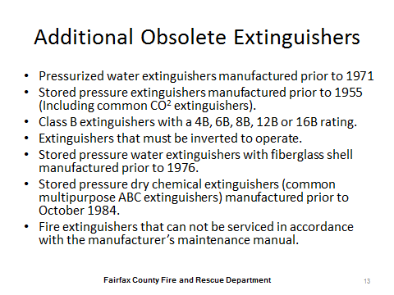

What You Should Know:
This is a list of extinguisher categories have been identified as obsolete according to the 2007 edition of NFPA 10. The additional categories of obsolete fire extinguishers do not represent a specific or new hazard as they were tested and approved under older testing requirements. However, it has been identified over time that some fire extinguishers may pose a risk of malfunction resulting in direct or indirect injury. Many of these obsolete fire extinguishers were manufactured prior to updated standards. Additionally, they may not follow current rating classifications, or could lack features incorporated into fire extinguishers approved under current standards.

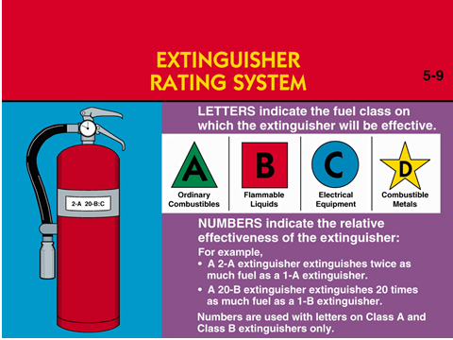
What You Should Know:
Firefighting equipment should be of the appropriate type and size. The markings on the extinguisher will assist you in determining if you have the right equipment for your situation.

The letters on the extinguisher indicate the type of fire that it is designed to extinguish, which would help you determine the right type. We will go over this in more detail later.

The numerical rating on the extinguisher is important to understand so that you know the capabilities of the extinguisher. This would help you determine if you have the right size.

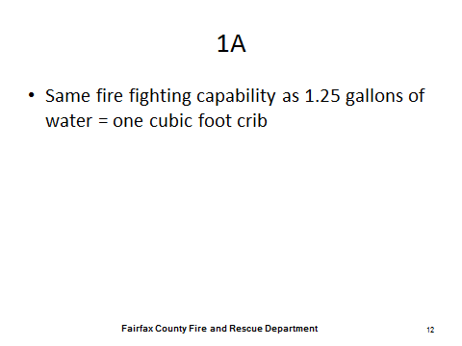
What You Should Know:
Prepare: Use the dry erase board or flip chart to do the math.
Class A extinguishers have a rating of 1 – 40A. A 1A extinguisher has the same firefighting capability as 1.25 gallons of water. A 6A extinguisher has the same firefighting capability as 6 – 1.25 gallon extinguishers, which would be the equivalent of 7 ½ gallons of water.

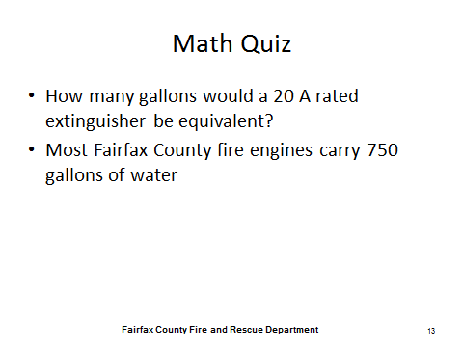
What You Should Know:
20A is equivalent to 25 gallons of water. As a point of reference a standard county engine carries 750 gallons.

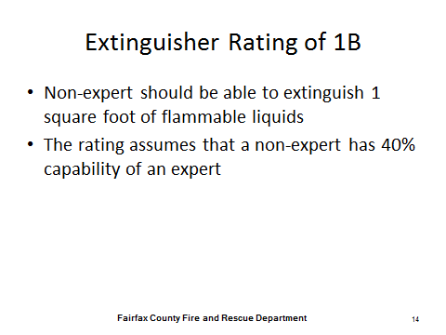
What You Should Know:
Prepare: Use the dry erase board or flip chart to do the math.

Class B extinguisher have a rating of 1 – 640. The ratings on a class B extinguisher are based upon the square footage that a non-expert should be able to put out using that extinguisher. The rating assumes that a non-expert has 40% of the ability of an expert. As an example, if you have a 60B extinguisher, a non-expert should be able to extinguish a fire that is 60 square feet, which is roughly a room that is 8 x 7.5 and an expert should be able to extinguish a fire that is 150 square feet, which is roughly a room that is 12 x 12 ½ with the same extinguisher.

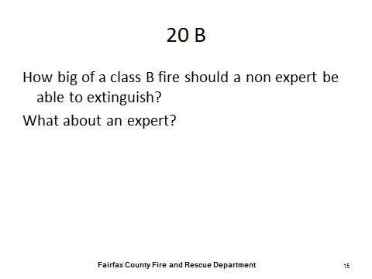
What You Should Know:
A non-expert could extinguish up to 20 square feet. An expert could put out up to 50 square feet.

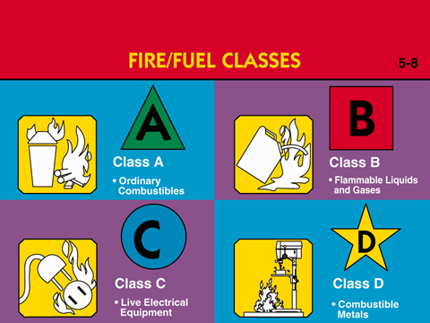
What You Should Know:
Extinguishers are classified for the type of fire they are designed to extinguish.
Class A fires are the most common and are comprised of ordinary combustibles
The class B rating is for flammable liquids and gases.
Class C extinguishers are designed for live electrical equipment.
Class D fires are made of combustible metals.
There is also one more class not listed here, which is Class K for kitchen grease fires.

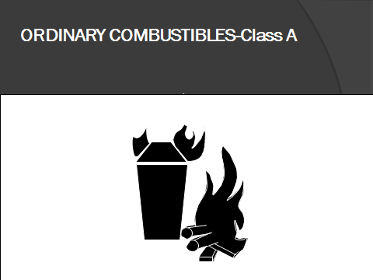

What You Should Know:
Class A fires are ordinary combustibles and consist of most items used to furnish your home, which include solid materials that are not metals. Examples include wood, paper, cloth, trash, and plastics. Class A fires usually leave ash. A = Ash. Ordinary combustibles can be extinguished with water.

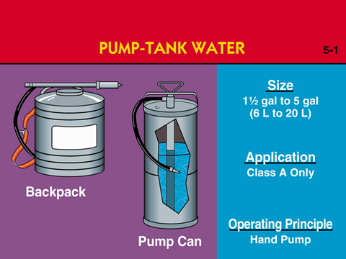

What You Should Know:
All engines and ambulances have an extinguisher filled with water, which is also known as a Water Can.

Stream Reach: 30-40 Feet
Discharge Time: 45 Seconds - 3 Minutes

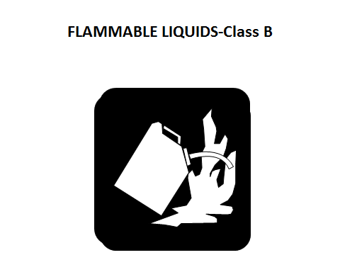
What You Should Know:
The class B rating is for any non-metal in a liquid or gas state to include gasoline, oil, grease, and acetone. Class B fires usually involve materials that boil or bubble or found in a barrel.

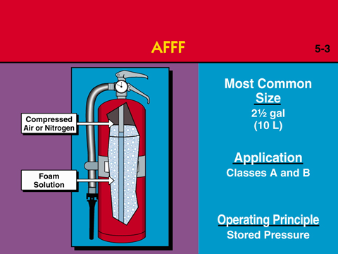

What You Should Know:
AFFF is short for Aqueous Film-Forming Foam and is a synthetic type of foam. Its role is to cool the fire and to coat the fuel, preventing its contact with oxygen.

AFFF works on Class A foams by lowering the surface tension of the water, which assists in the wetting and saturation of Class A fuels. This aids fire suppression and can prevents re-ignition. You will hear that it makes water wetter.

For Class B fuels, the foam has the ability to spread over the surface creating a thin layer of film to reduce explosive vapors.

Stream Reach: 20-25 Feet
Discharge Time: 50 Seconds

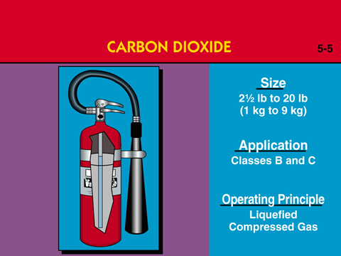
What You Should Know:
Carbon dioxide extinguishers work by cooling the fire and removing oxygen from the area surrounding the fire. This type of fire extinguisher contains a mixture of liquid and carbon dioxide (CO2), which is a non-flammable gas.
Since carbon dioxide is a gas at room temperature, in order for it to exist in liquid form, the gas must be stored at extremely high pressure. When the pressure is released from the extinguisher, the gas expands, cooling the air and shooting out a white cloud resembling snow. Because the gas is so pressurized, dry ice may stream from the extinguisher or form around the horn when in use.
Since carbon dioxide extinguishers do not have a gauge, if the pin is not secure you should assume that the extinguisher is empty.
Stream Reach: 3-8 Feet
Discharge Time: 8-30 Seconds
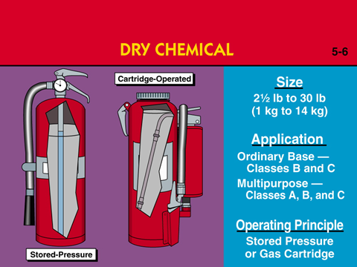

What You Should Know:
Prepare: Make sure you have a dry chemical extinguisher.
Dry chemical extinguishers work by cooling the fire and coating the fuel to stop oxygen from reaching the fuel.

Shake before you use it. Remember to also shake it during daily checks.

Stream Reach: 5-20 Feet
Discharge Time: 8-25 Seconds

When using a dry chemical or powder extinguisher, make sure to keep it straight. If you turn it sideways, you may only get air coming out and not the powder. We will be practicing with this type of extinguisher today. In order to ensure the extinguisher is in the vertical position, set it on the ground to use it. Demonstrate: Without discharging, exhibit how to use the PASS acronym while the extinguisher is set on the ground.

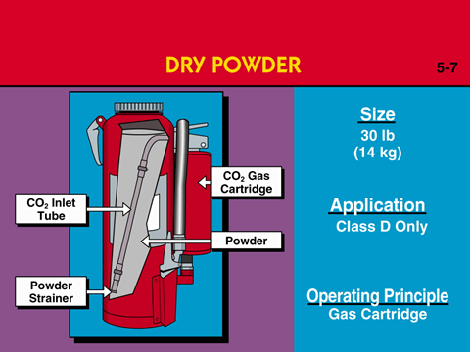

What You Should Know:
Dry powder extinguishers work by cooling the fire and coating the fuel to stop the oxygen from reaching the fuel. Powder fire extinguishers contain a pressurized gas such as nitrogen, and a powder such as sodium bicarbonate (baking soda).

When using this extinguisher, make sure to keep it straight. If you turn it sideways, you may only get air coming out and not the powder. We will be practicing with this type of extinguisher today. In order to ensure the extinguisher is in the vertical position, set it on the ground to use it.
Stream Reach: 4-6 Feet
Discharge Time: 20-30 Seconds

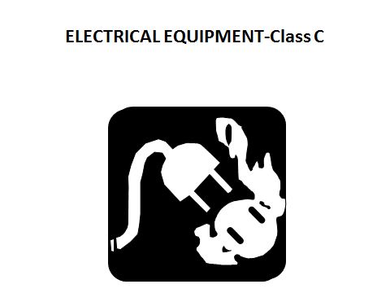
What You Should Know:
Class C extinguishers are designed for live electrical equipment. You can remember Class C for Current. For class C fires, you can de-energize the item (you know, unplug it) and treat as Class A (or Class D).

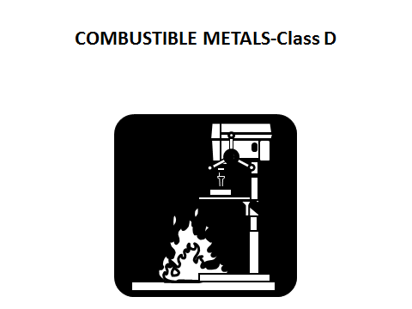

What You Should Know:
Class D fires are made of combustible metals such as potassium, aluminum, and magnesium. Most plants that have combustible materials usually have Purpole K, which is a dry chem agent readily available. It is usually in a big bin and can be scooped out.
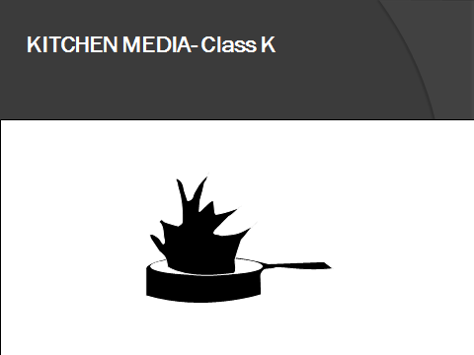

What You Should Know:
Prepare: Make sure video plays and is keyed up. Play video here.

Class K fires is for cooking fats and oil. You can remember Class K is for kitchen fires. Though such fires are technically a subclass of Class B fires and can be put out with the same extinguishers as Class B fires, the special characteristics of these types of fires are considered important enough to recognize separately.

Human fat has been identified as one of the most flammable mammal fats in the world so caution should be practiced when around fires that require human interaction such as cooking on the stove or grill.

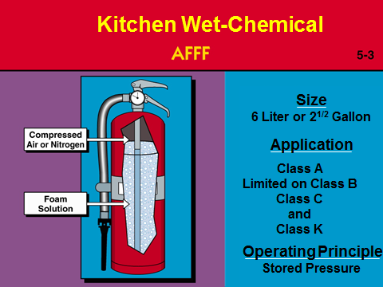
What You Should Know:
Stream Reach: 2 - 4 Feet
Discharge Time: 45 - 60 Seconds
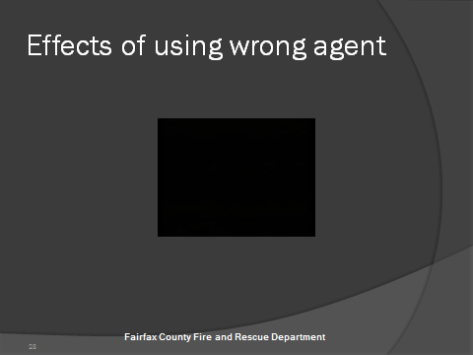

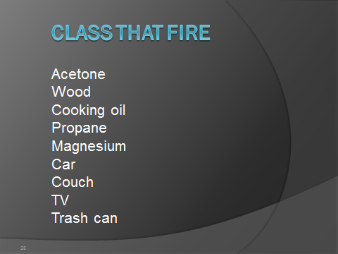
What You Should Know:
We are going to test your knowledge of classifying types of fires. Can anyone tell me what class of fire a (insert from list) would be?

Acetone – Class B
Wood – Class A
Cooking Oil – Class K
Propane – Class B
Magnesium – Class D
Car – Class B
Couch – Class A
TV – Class C
Trash Can – Class A

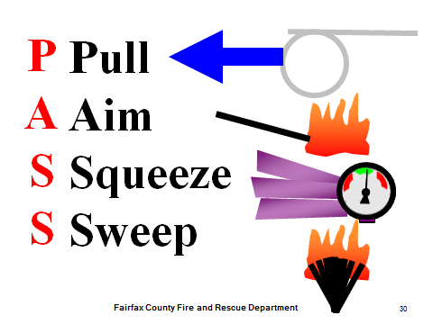

What You Should Know:
The acronym to remember when operating a fire extinguisher is PASS.

Demonstrate: Without discharging, exhibit the PASS acronym while explaining each step.
Pull the Pin at the top of the extinguisher. The pin releases a locking mechanism and will allow you to discharge the extinguisher.
Aim at the base of the fire, not the flames. This is important - in order to put out the fire, you must extinguish the fuel.
Squeeze the lever slowly. This will release the extinguishing agent in the extinguisher. If the handle is released, the discharge will stop.
Sweep from side to side. Using a sweeping motion, move the fire extinguisher back and forth until the fire is completely out. Operate the extinguisher from a safe distance, several feet away, and then move towards the fire once it starts to diminish. Remember: Aim at the base of the fire, not at the flames!!!!

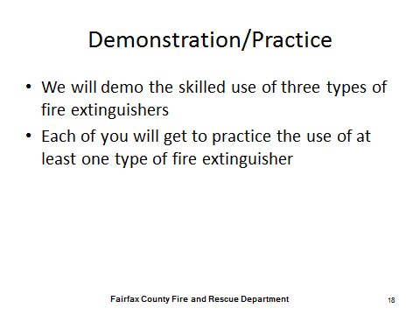

What You Should Know:
You should be able to identify the differences in the skilled demonstration and the unskilled practice each of you will have.

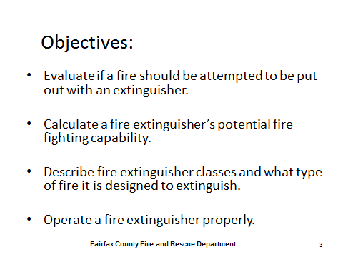
What You Should Know:
Here are our four learning objectives for this evening’s class. If you feel they were not covered appropriately, please let me know and one of the instructors will gladly answer any questions you may have.

- Evaluate if a fire should be attempted to be put out with an extinguisher.
- Calculate a fire extinguisher’s potential firefighting capability.
- Describe fire extinguisher classes and what type of fire it is designed to extinguish.
- Operate a fire extinguisher properly.

